**Documentation**

*Team Musketeers*

*Date: 10.05.2022*

# Team members

Abdul-Azeez Olanlokun 2180593

Elijah Nnamdi Obi 2190345

George Izuchukwu Enekwa 2190317

Patric Nonki 2190336

# Concept description

*Block diagram of your target application.*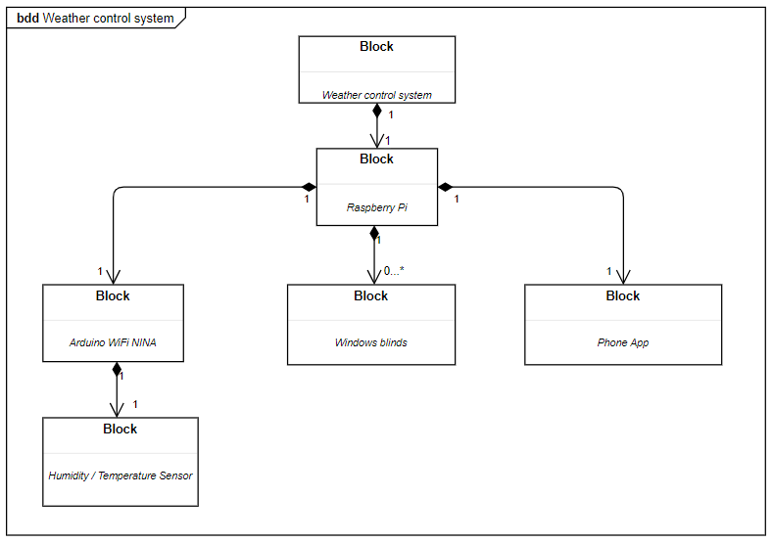

*Weather reporting system: Our system is supposed to get weather conditions, print it on an app via WiFi communication and then based on values we turn on the Green LED and open the windows when the weather is good and turn on the Red LED and close the window when the weather is bad.*

*We use the following devices, sensors and App for our project:*

* *Raspberry Pi*
* *Arduino WIFI Rev. 2*
* *KY-015 DHT11 Humidity and Temperature sensor*
* *KY-028 Temperature sensor*
* *MIT App Inventor*
* *Jumping wires*
* *Red and Green LEDs*
* *5v Dc Motor*
* *LCD 16/2*

# Project/Team management

*Which project methods you used in your project?*

*The project management method used was agile methodology, specifically scrum, where we had weekly sprint sessions(physically). Complex tasks were broken down to smaller bits and assigned to individuals.*